Answers Question 1

(i) Vector Diagram

d
θ
θ

If the phase of the light from the first slit is zero, the phase from second slit is
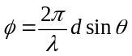
Adding the two waves with phase difference where 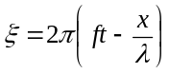,
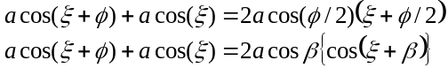
This is a wave of amplitude 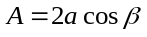and phase β. From vector diagram, in isosceles triangle OPQ,

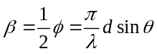

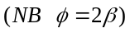

and
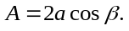
Thus the sum of the two waves can be obtained by the addition of two vectors of amplitude a and angular directions 0 and .
(ii) Each slit in diffraction grating produces a wave of amplitude a with phase 2β relative to previous slit wave. The vector diagram consists of a 'regular' polygon with sides of constant length and with constant angles between adjacent sides.
Let O be the centre of circumscribing circle passing through the vertices of the polygon. Then radial lines such as OS have length R and bisect the internal angles of the polygon. Figure 1.2.

Figure 1.2
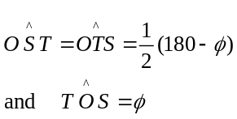
In the triangle TOS, for example

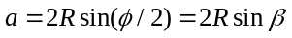 as 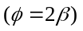
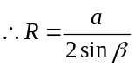 (1)

As the polygon has N faces then:
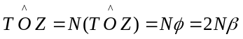

Therefore in isosceles triangle TOZ, the amplitude of the resultant wave, TZ, is given by

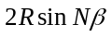.

Hence form (1) this amplitude is

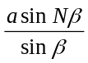

Resultant phase is
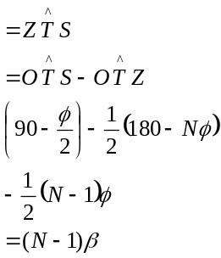
(iii)

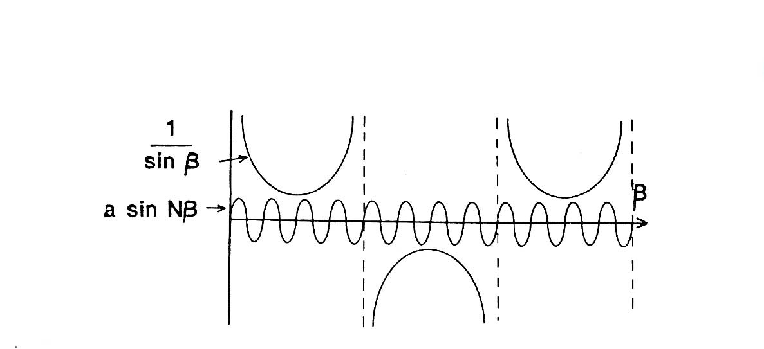
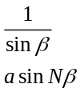
β

Intensity 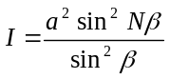

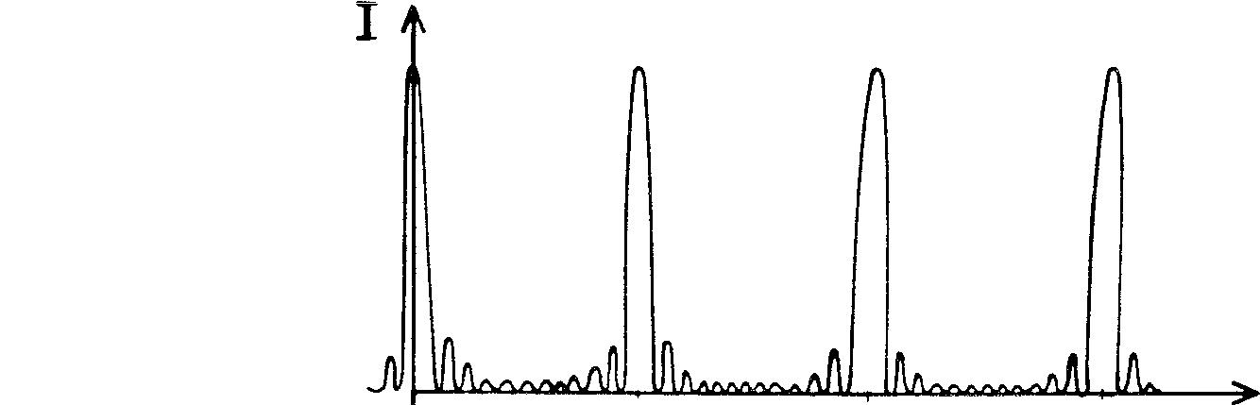
I
β
37C
0 π 2π 3π

(iv) For the principle maxima 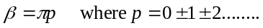

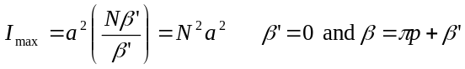

(v) Adjacent max. estimate I₁ :

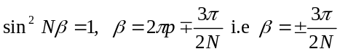

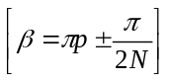 does not give a maximum as can be observed from the graph.
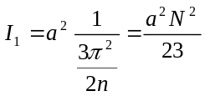 for N>>1

Adjacent zero intensity occurs for 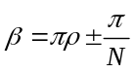 i.e. 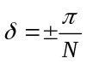

For phase differences much greater than 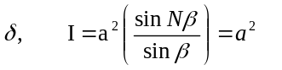.

(vi)
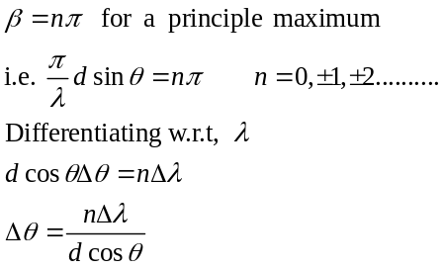

Substituting
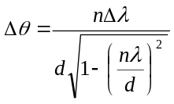 as 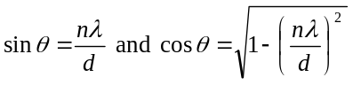
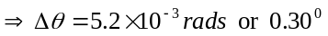

θ
θ
R
O
R
φ
E
X
X’
2.(i)
Figure2.1
Answers Q2

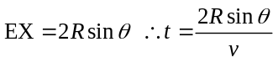
where v = v_{P} for P waves and v = v_{S} for S waves.

This is valid providing X is at an angular separation less than or equal to X', the tangential ray to the liquid core. X' has an angular separation given by, from the diagram,

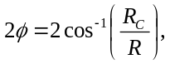
Thus
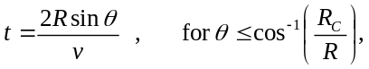
where v = v_{P} for P waves and v = v_{S} for shear waves.

(ii) 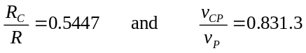

Figure 2.2

r
O
X
E
B
A
C
R_{c}
θ
i

From Figure 2.2

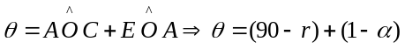 (1)
(ii) Continued

Snell’s Law gives:

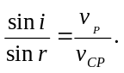 (2)

From the triangle EAO, sine rule gives
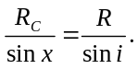 (3)

Substituting (2) and (3) into (1)

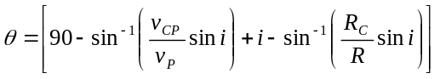 (4)

(iii)

For Information Only

For minimum 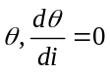. 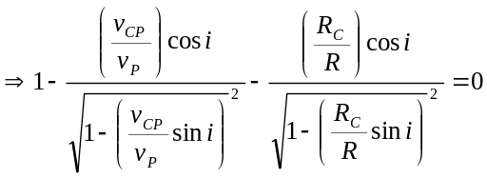
Substituting i = 55.0º gives LHS=0, this verifying the minimum occurs at this value of i. Substituting i = 55.0º into (4) gives θ = 75.8⁰.

Plot of θ against i.

90⁰
75.8⁰
0
55⁰
90⁰

Substituting into 4:
i = 0 gives θ = 90
i = 90° gives θ = 90.8°
Substituting numerical values for i = 0 90° one finds a minimum value at i = 55°; the minimum values of 0, θ_{MIN} = 75•8°.

Physical Consequence

As θ has a minimum value of 75•8° observers at position for which 2 θ <151•6° will not observe the earthquake as seismic waves are not deviated by angles of less than 151•6°. However for 2 θ 114° the direct, non-refracted, seismic waves will reach the observer.

0 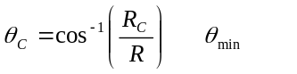 90⁰
Refracted
waves
θ

90⁰

180⁰
(iv) Using the result

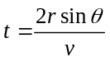
the time delay Δt is given by

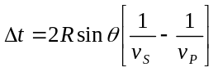

Substituting the given data

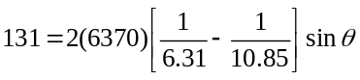

Therefore the angular separation of E and X is

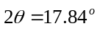

This result is less than 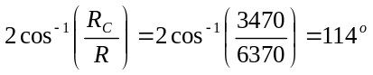
And consequently the seismic wave is not refracted through the core.
(v)
R_{C}
E
X
Y
R
R
D
θ
θ
O

The observations are most likely due to reflections from the mantle-core interface. Using the symbols given in the diagram, the time delay is given by

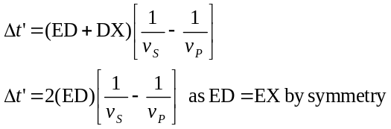

In the triangle EYD,

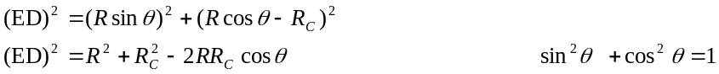
Therefore
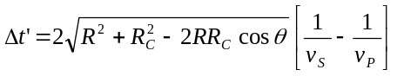
Using (ii)

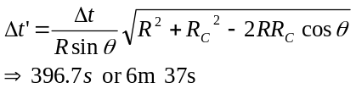

Thus the subsequent time interval, produced by the reflection of seismic waves at the mantle core interface, is consistent with angular separation of 17.84⁰.

Answer Q3
Equations of motion:

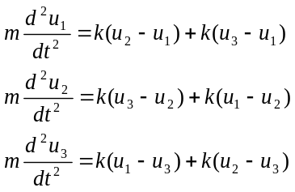

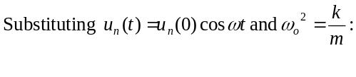
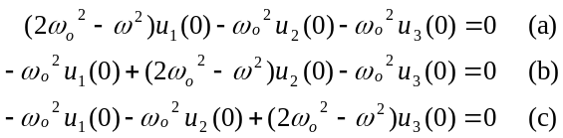
Solving for u₁(0) and u₂(0) in terms of u₃(0) using (a) and (b) and substituting into (c) gives the equation equivalent to
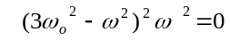
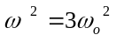, 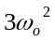 and 0
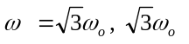and 0

(ii) Equation of motion of the n’th particle:
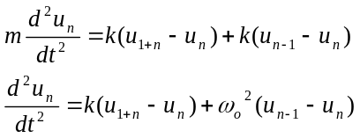
n = 1,2……N
Substituting 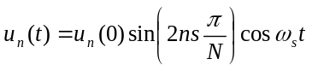
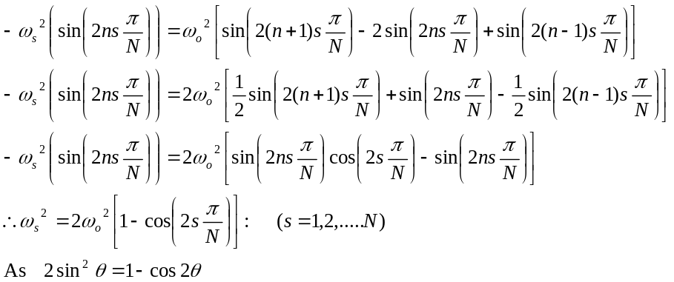
This gives
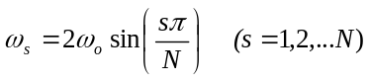
(iv) For s’th mode

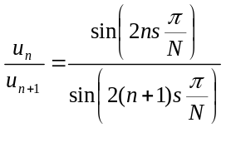
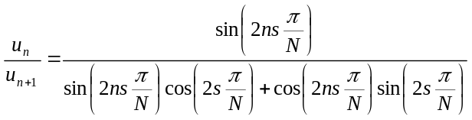

(a) For small 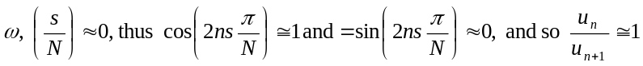.
(b) The highest mode, 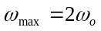, corresponds to s = N/2

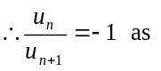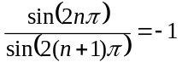

Case (a)
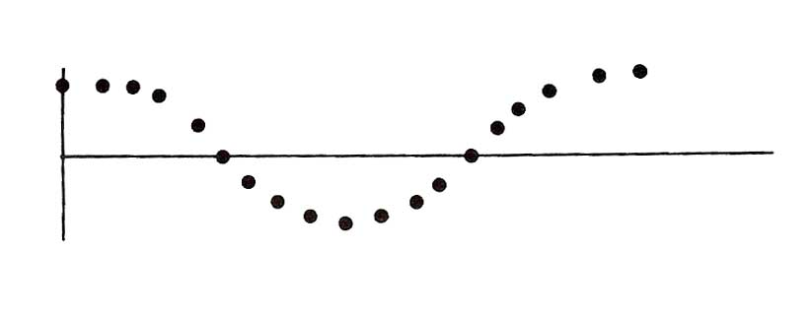
Case (b)
N odd
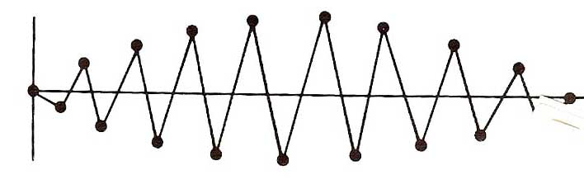

N even
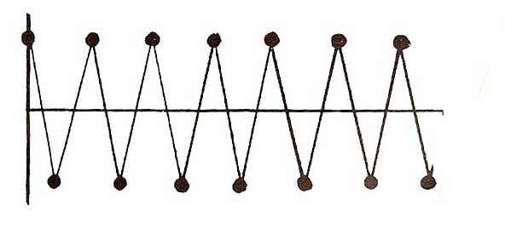

(vi) If m' << m, one can consider the frequency associated with m' as due to vibration of m' between two adjacent, much heavier, masses which can be considered stationary relative to m'.

The normal mode frequency of m', in this approximation, is given by

m‘
m
m

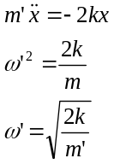

For small m', ω' will be much greater than ω_{max},

0 2ω_{o} ω ω
BAND

DIATOMIC SYSTEM
More light masses, m', will increase the number of frequencies in region of ω' giving a band-gap-band spectrum.
BAND
GAP
BANDDD
0 ω

